CUDA PROGRAM

1.open google.com
2.signin to ur mail
3.open new tab and go to
https://colab.research.google.com/notebooks/welcome.ipynb#scrollTo=cPqhK9GsnclA

4. click on

- Runtime ->Change Runtime type
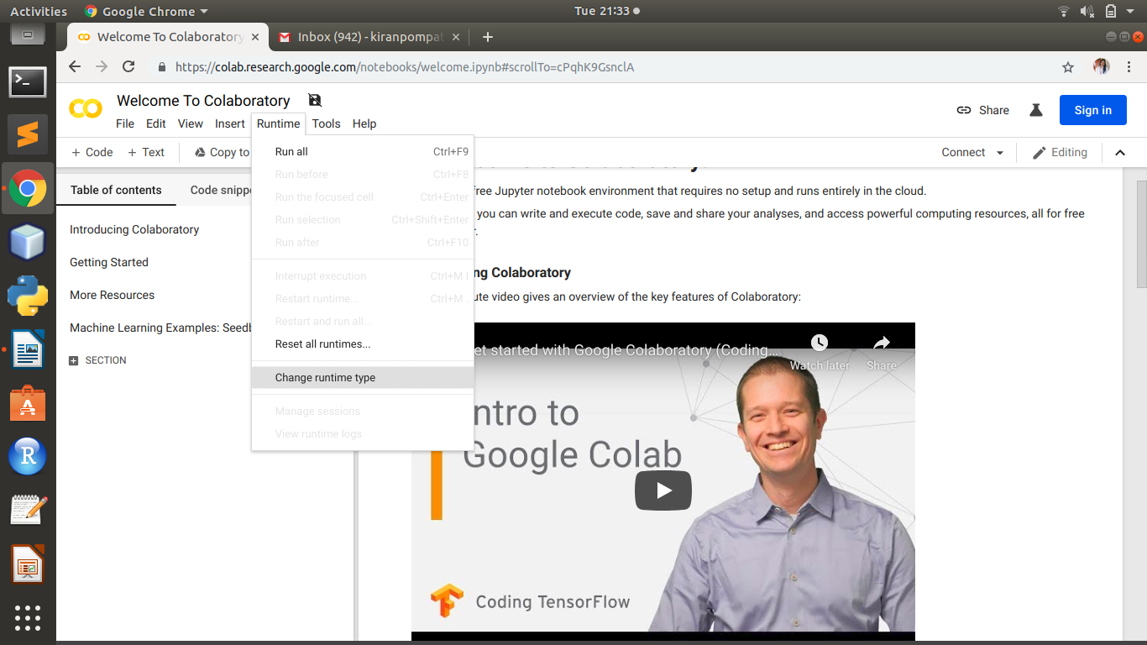

- Select
Runtime type =python and
Hardware accelerator =GPU
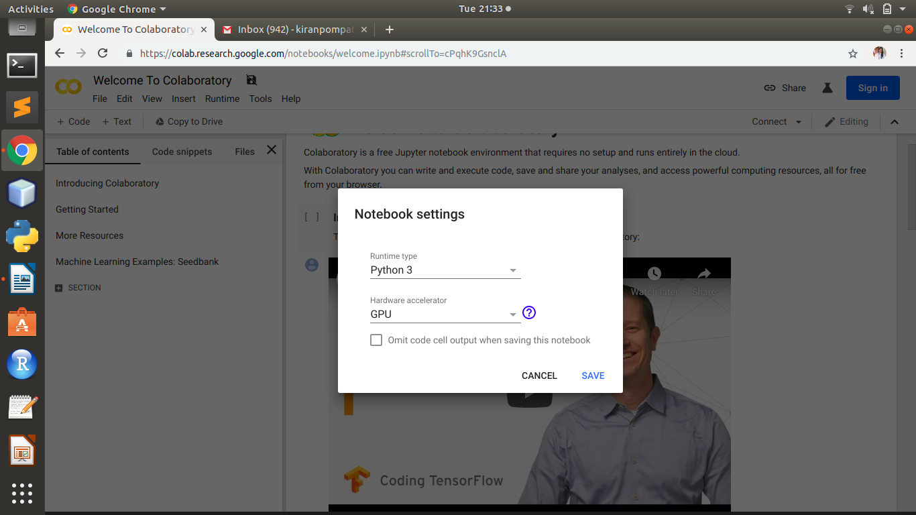

5. Click on
connect -> connect to hosted runtime ( u may get popup ->click on leave page)

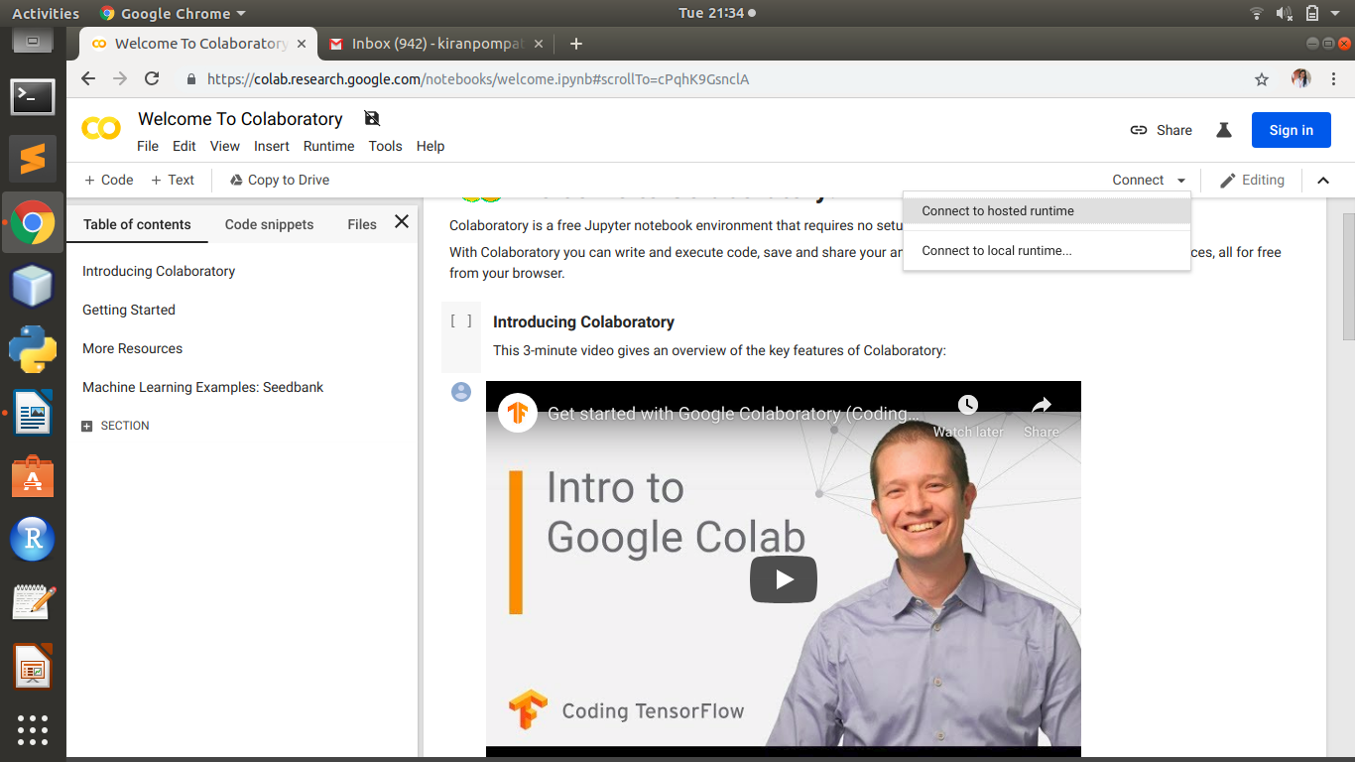

6. click on
+code

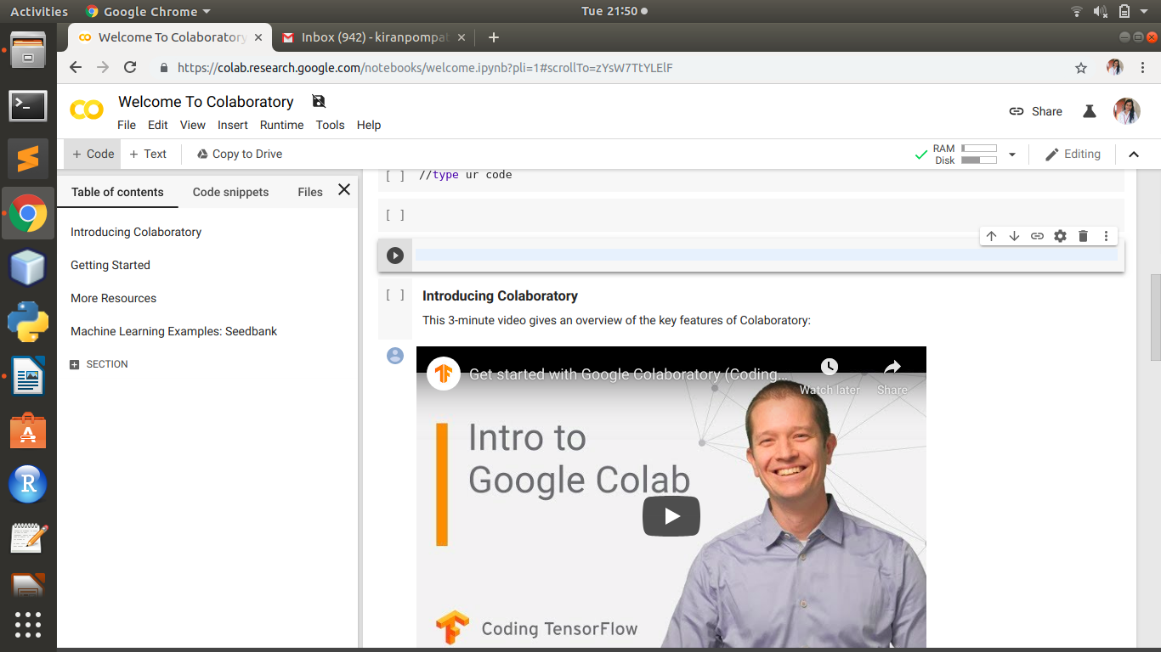
Type Here
7.write the following steps:
step 1:- !/usr/local/cuda/bin/nvcc --version(click on run cell)
step 2:- click on +code
!pip install git+git://github.com/andreinechaev/nvcc4jupyter.git
step 3:- click on +code
%load_ext nvcc_plugin
step 4:- click on +code
type ur code (write %%cu and then code)
